Compare Targets Report (National/Jurisdiction/State Percentile Columns)
And The Relationship of Percent to Percentile

Short-term Acute Care Hospital Compare Targets Report, Data Table and Graph
Below is a screenshot of a portion of a Compare Targets Report for a short-term acute care hospital, P2786. Please note the columns titled “Hospital National %ile”, “Hospital Jurisdict. %ile” and “Hospital State %ile.” The values in these three columns represent the hospital’s percentiles compared to all short-term acute care hospitals within the nation, the Medicare Administrative Contractor (MAC) jurisdiction, and the state, for the Stroke/Intracranial Hemorrhage target area during Q1 FY 2014 for short-term acute care hospital P2786. In addition there are screen shots of the associated target area data tables with graphs.
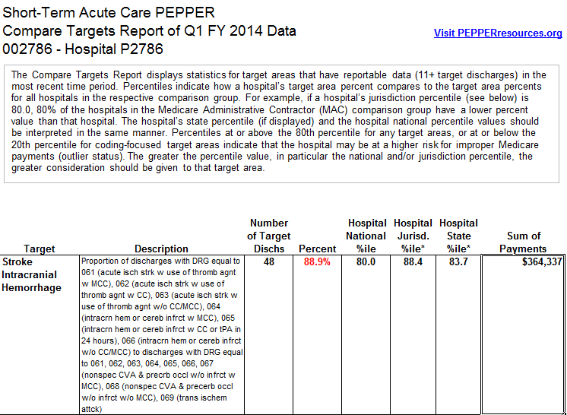
The Compare Targets Report displays the statistics for the most recent time period in the report (Q1FY14). Note that the percent 88.9 % for the Stroke Intracranial Hemorrhage target area for Q1 FY 2014 is at the 80.0 percentile within the nation (80th percentile and above within the national comparison group is outlier status in PEPPER), 88.4 percentile within the MAC jurisdiction and 83.7 percentile within the state. This means that for this target area and time period, hospital P2786’s target area percent of 88.9% is greater than 80 percent of all hospitals in the nation, than 88.4 percent of all hospitals in the jurisdiction comparison group, and 83.7 percent of all hospitals in the state comparison group.
The following are screenshots of hospital P2786’s Stroke Intracranial Hemorrhage target area data table (note the hospital’s Q1 FY 2014 percent value of 88.9%) and target area graph and Comparative Data for Target Proportion table, with the National 80th percentile for Q1FY14 noted as 88.9%.
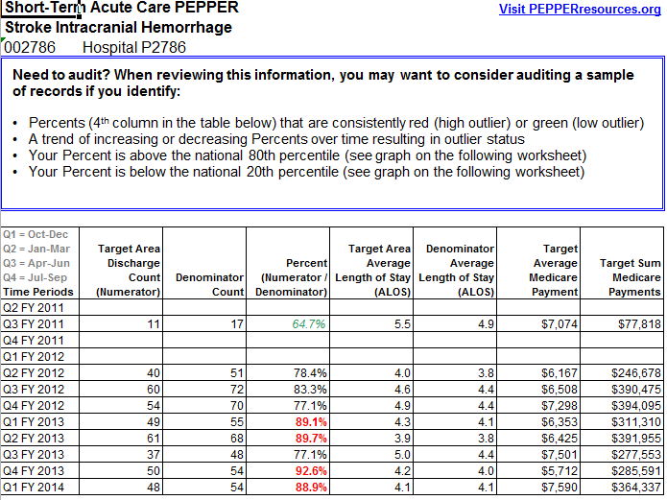
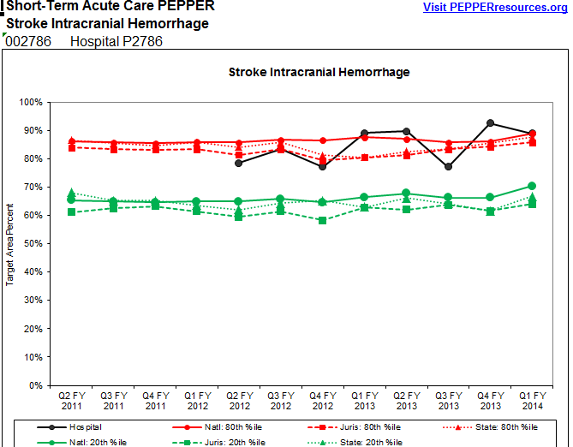
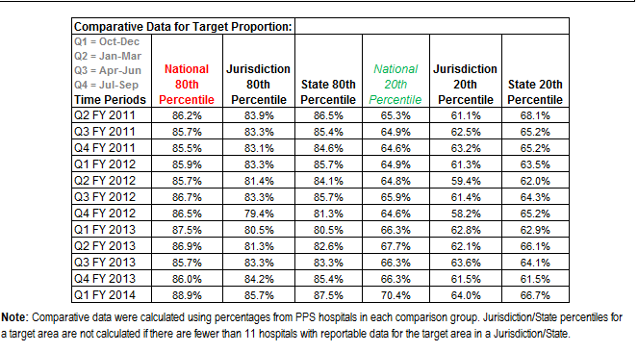
In summary, for Q1 FY 2014 hospital P2786’s percent for the Stroke Intracranial Hemorrhage target area was 88.9%. To have been identified as a high outlier in PEPPER for this time period, the hospital’s percent would have had to have been 88.9% or greater as compared to all short-term acute care hospitals in the nation. To have been identified as a low outlier in PEPPER for this time period, the hospital’s percent would have had to have been 70.4% or lower as compared to all short-term acute care hospitals in the nation. The jurisdiction and state 80th and 20th percentile values are displayed for comparative purposes.
Critical Access Hospital (CAH) Compare Targets Report, Data Table and Graph
The Compare Targets Report for a critical access hospital (CAH), H0905, is constructed in the same manner as that for the short-term acute care hospital (see the screenshot below which shows a portion of the Compare Targets Report for CAH H0905). The columns titled “Hospital National %ile”, “Hospital Jurisdict. %ile” and “Hospital State %ile” include the hospital’s percentiles compared to all CAHs within the nation, the Medicare Administrative Contractor (MAC) jurisdiction, and the state, for the Stroke/Intracranial Hemorrhage target area for the most recent time period in the report, Q4FY13. Note that the percent of 91.7 % for the Stroke/ Intracranial Hemorrhage target area for Q4 FY 2013 is at the 84.4 percentile within the nation (80th percentile and above within the national comparison group is outlier status in PEPPER), and 92.0 percentile within the MAC jurisdiction. There is no state percentile displayed because there are fewer than 11 CAHs with reportable data for the Stroke/Intracranial Hemorrhage target area for the Q4FY13 time period within that state. This means that for this target area and time period, hospital H095’s target area percent of 91.7% is greater than 84.4 percent of all CAHs in the nation and 92.0 percent of all CAHs in the jurisdiction comparison group.
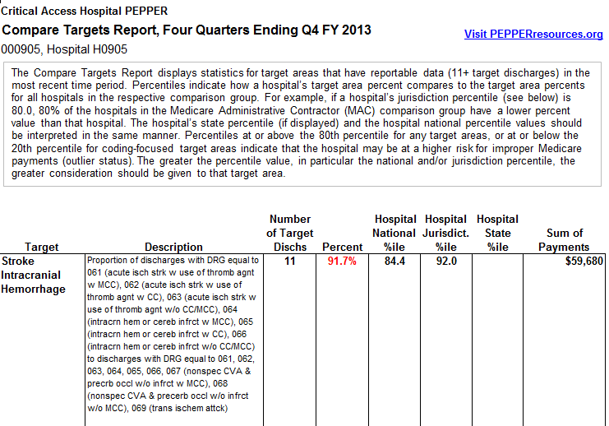
The following is a screenshot of hospital H0905’s Stroke/Intracranial Hemorrhage target area report. Note the most recent time period, 10/01/2012–09/30/2013, with hospital H0905’s target area percent value of 91.7% and the Comparative Data table, National 80th percentile value of 90.0% and National 20th percentile value of 70.4%. For CAHs, outlier status in PEPPER is determined by comparison of a CAH with all other CAHs in the nation.
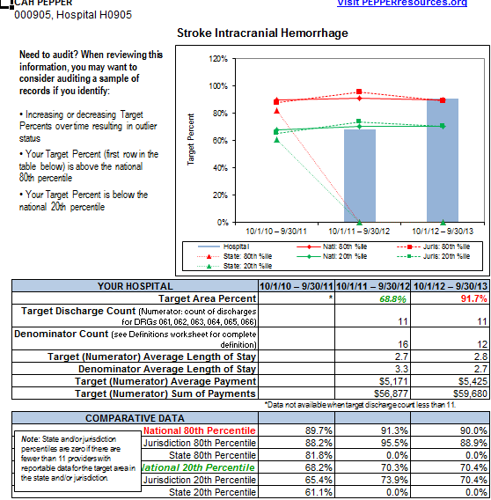
The Compare Targets Report and Target Area Report for other types of PEPPERs (those for long-term acute care hospitals, inpatient psychiatric facilities, inpatient rehabilitation facilities, hospices, partial hospitalization programs and skilled nursing facilities) are structured in the same manner and are interpreted in the same way as for critical access hospitals.

